Ferrell-Duncan Clinic Allergy/Immunology
Dr. Minh-Thu Le, MD; Dr. Bill Micka, MD
1001 E. Primrose, Springfield, MO 65809
Phone: (417) 875-3742; Fax: (417) 875-3383
How to Use Your Inhaler
About Spacers
Also known as aerosol-holding chambers, add-on devices and spacing devices, spacers are long tubes that slow the delivery of medication from pressurized MDIs.
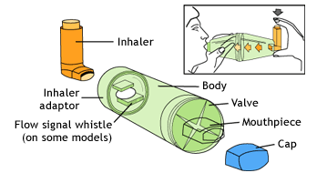
To Use a Spacer:
- Shake the inhaler well before use (3-4 shakes)
- Remove the cap from your inhaler, and from your spacer, if it has one
- Put the inhaler into the spacer
- Breathe out, away from the spacer
- Bring the spacer to your mouth, put the mouthpiece between your teeth and close your lips around it
- Press the top of your inhaler once
- Breathe in very slowly until you have taken a full breath. If you hear a whistle sound, you are breathing in too fast. Slowly breathe in.
- Hold your breath for about ten seconds, then breathe out.
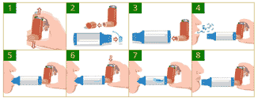
Cleaning Your Spacer
To clean your spacer, follow the instructions that come with it. In most cases, they will advise you to:
- Take the spacer apart.
- Gently move the parts back and forth in warm water using a mild soap. Never use high-pressure or boiling hot water, rubbing alcohol or disinfectant.
- Rinse the parts well in clean water.
- Do not dry inside of the spacer with a towel as it will cause static. Instead, let the parts air dry (for example, leave them out overnight).
- Put the spacer back together.
Important Reminders About Spacers
Always follow the instructions that come with your spacer. As well:
- Only use your spacer with a pressurized inhaler, not with a dry-powder inhaler.
- Spray only one puff into a spacer at a time.
- Use your spacer as soon as you've sprayed a puff into it.
- Never let anyone else use your spacer.
- Keep your spacer away from heat sources.
- If your spacer has a valve that is damaged, or if any other part of the spacer is damaged, do not use it. The spacer will have to be replaced.
- Some spacers have a whistle. Your technique is fine if you do not hear the whistle. However, if you hear the whistle, this means you should slow your breath down.
- It is very important that you consult your doctor, asthma educator or other healthcare professional to review proper inhaler technique.

